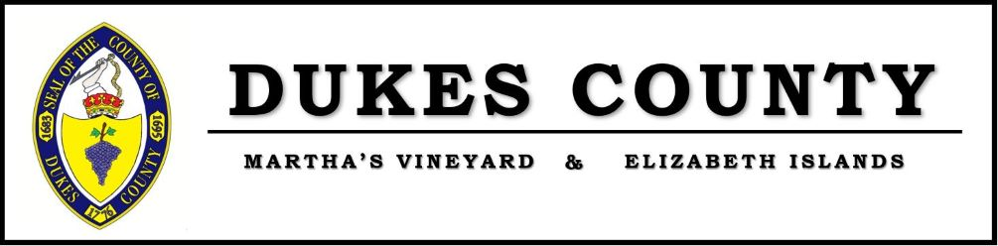

Dukes County Social Services Annual Report FY22
Supervisor: Sarah Kuh, MPH skuh@mvhealthcareaccess.org
Social Services Caseworker: Delilah Meegan socialservices@dukescounty.org
Phone: (508) 696-3844
Physical Address: 9 Airport Road, Edgartown MA
Mailing Address: P.O. Box 190, Edgartown MA 02539

Background
In 2015 Dukes County created its Social Services Department (DCSS) in response to the community’s need for assistance with safety net programs, public benefits, and resources for low-income Islanders under age 60. DCSS connects needy Islanders with a variety of programs and services that support economic self-sufficiency. The population that the department serves ranges in age, socio-economic status, and education levels. We provide services in English, Portuguese, and Spanish.
DCSS Funding
The department is funded by the six towns of Martha’s Vineyard and grants from the Community Action Committee for the Cape and Islands (CACCI), the USDA via DTA’s SNAP Outreach Grant from UMass Medical School, and the South Shore Community Action Committee Fuel Assistance Program. We are staffed by a full-time Social Service Caseworker.
DCSS Services
The Social Services department’s primary functions include, but are not limited to, application assistance for the following programs:
- SNAP (Supplemental Nutrition Assistance Program/Food Stamps)
- WIC (Women, infants, and children)
- Department of Transitional Assistance cash assistance for families with children and disabled adults
- Fuel Assistance
- Utility Assistance
- Unemployment benefits
- Emergency and non-emergency food programs
- Social Security Disability Income and Supplemental Security Income
- CARES Act application for Utility, Car Repairs, Rental Assistance
The Department provides information and referrals to local and regional agencies that can offer services and resources to complete addressing the needs of every client and household that we serve. DCSS facilitates applications and referrals for childcare subsidy programs including Bailey Boyd and voucher programs, emergency housing and rental assistance, Cape Cod Times Needy Fund, and unemployment insurance.
Clients receive application assistance for outside agencies that address housing and homelessness and are advised of their options as to what is available to them in terms of rental assistance, housing search assistance and support, homeless shelters, and programs available as well as resources that can support presently homeless individuals. DCSS works closely with the County’s Homelessness Prevention Program, Harbor Homes, and the Warming Shelter.
Information and referrals are made to agencies like the Housing Assistance Corporation, Massachusetts Rehabilitation Commission, the Cape Cod Organization for the Rights of the Disabled (CORD), and Community Action Committee for the Cape and Islands (CACCI). Locally, the department collaborates with organizations ranging from Elder Services, Councils on Aging, Martha’s Vineyard Hospital, Martha’s Vineyard Community Services, The Resource Institute, Salvation Army, The Clergy Fund, Vineyard Housing Office, the Vineyard Committee on Hunger, Vineyard Health Care Access Program, and many additional agencies on the island.
Local and regional agencies refer their clients to the Social Services Department as a valuable and helpful resource. The outcome of this collaboration is that clients receive complete wrap around services in a multitude of areas.
In collaboration with CACCI, the Department sponsors the Volunteer Income Tax Assistance Program, which is an island wide, free tax preparation program, geared towards households under the age of 65 from January through April.

APPLICATIONS
Applications submitted in FY22 for state and federal assistance on behalf of individuals and families who are Island residents.
In FY21 DCSS submitted:
- 27 CARES Act Applications on behalf of 50 individuals for utility assistance, car repair and rental assistance
- 87 SNAP applications on behalf of 110 individuals
- 4 SNAP Recertification Applications on behalf of 4 individuals
- 16 Fuel Assistance applications on behalf of 25 individuals
- 1 Fuel Assistance Recertification Application on behalf of 3 individuals
- 2 Social Security Disability Applications
- 4 Housing Application’s on behalf of 4 individuals
- 11 Emergency Cash Assistance applications for 11 individuals
- 32 Utility Assistance Applications on behalf of 48 individuals
- 5 Unemployment applications were made
- 3 Transitional Aid to Families with Dependent Children Applications on behalf of 6 individuals
DCSS is a SNAP Outreach Partner via our contract with the Commonwealth Medicine SNAP Unit at the University of Massachusetts Medical School. We participate in trainings and receive regular updates to stay current on changes to SNAP and related programs. The County also hosts an annual site review to ensure we are meeting our program goals and objectives. Sarah Kuh is an Island representative to the Department of Transitional Assistance Cape and Islands Advisory Board.
ASSISTANCE
Assistance includes information, referral, follow-up, and advocacy for social services related to client self-sufficiency.

