HEALTHY AGING MV

HAMV is a planning, advocacy and community building organization. Our mission is to ensure that the infrastructure and services are in place to serve our Aging Adults and those who care for them. Our fiscal agent is MVCS. HAMV is funded in part by the six towns of Martha’s Vineyard through a contract between the County of Dukes County and MVCS. Other funding sources, which made up over 50% of our budget in FY2023 are grants from local, national and private organizations and foundations, and donations from churches, organizations and individuals.

HAMV conducts research and educates the community about Aging Adult needs and their contributions to the island, plans and advocates for new or improved services to meet those needs, and builds community-wide support through engaging stakeholders of all ages to bring these goals into reality. Once service and infrastructure gaps are identified, HAMV and coalition partners create pilot programs to address these needs and identifies funding sources for the pilot phases.

The following graphic illustrates the interconnectedness of HAMV with other on- and off-island organizations serving Aging Adults. As a planning and advocacy organization, we act as catalyst to create collaboration to identify and address the needs of Aging Adults. More information on HAMV can be found at our website https://www.hamv.org/
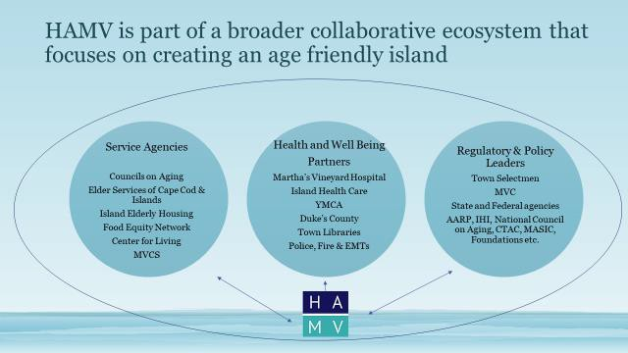

HAMV’s Accomplishments - FY2023 (July 1, 2022- June 30, 2023)

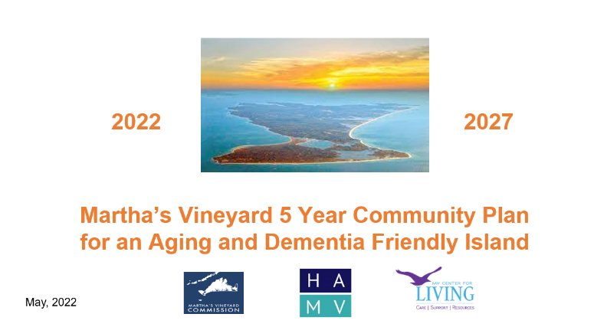

- The completion of a 5 year Community Plan to address the six key priorities with specific action steps, collaborating with community partners, and a timeline for action. Worked with MVC4L to include a dementia inclusive “lens” to our collective actions.

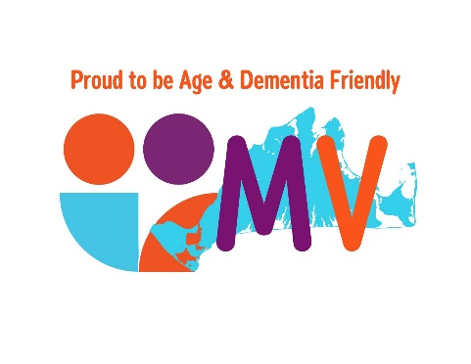
- Submission of the plan to the World Health Organization/AARP. We received a 5 year age-friendly designation again for all six towns as part of the MA Healthy Aging Collaborative. For the first time, we also obtained dementia-friendly designation as well. In addition to highlighting statewide Martha’s Vineyard commitment to Aging Adults, this designation creates opportunities for partnerships with regional and national organizations as well as access to additional funding sources.

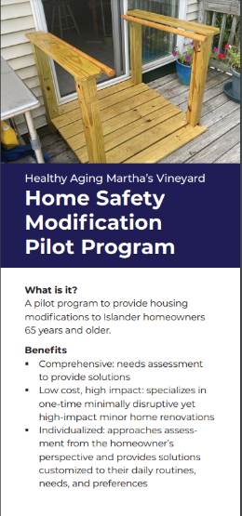
- Completed the 2nd full year of a pilot program for an island-wide Home Safety Modification Program for 65+ homeowners (or those with disabilities), working with Martha’s Vineyard Builders Association and local contractors. The pilot program is referral based (from COAs, MVH, MVD4L, Elder Services etc.) and includes conducting a home assessment for minor home safety renovations (i.e. grab bars, stair railings, improved lighting, pull-out shelves etc.), matching the participant with a willing contractor to conduct the renovations, and providing a post-renovation assessment of the project. Obtained grant funding in excess of $50,000 from MVH and MVSBCF and private donations to fund this program. There have been 75 applicants with 62 projects completed as of June, 2023. Almost 70% of participants qualified to have 100% of the costs covered.

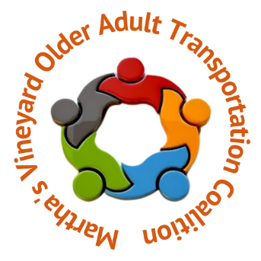
- Continued the 2nd year of the Older Adult Transportation Coalition and led monthly meeting with the Aging Adult Transportation Coalition, consisting of over 15 service agencies including the VTA and Steamship Authority, to address the needs for alternative transportation options for Aging Adults, both on- and off-island. The coalition implemented 4 pilot programs for alternative transportation options for Aging Adults including:

          - GoGoGrandparents on-demand rides (on-island)
          - MVC4L adult supportive day program (on-island)
          - COA Shopping Shuttle transportation (on-island)
          - Shuttle (including escorts) for islanders who are having cataract surgery (off-island)

In FY2023, over 4,000 rides were provided serving over 350 individuals. Over $80,000 in grants and donations were raised to support these programs in addition to utilizing existing island assets (e.g. VTA vans).

Received funding for a new role - an island-wide Mobility Manager - a resource to help Older Adults and service agencies identify and register for transportation options.

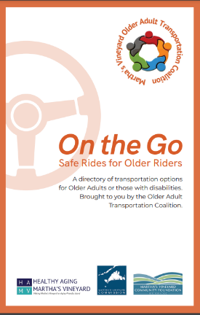
- Conducted the first in-person Aging Adult Transportation Summit in Sept, 2022 at the Martha’s Vineyard Film Center with over 100 attendees. The purpose of the summit was to raise awareness of Aging Adult transportation challenges, provide education on the new pilot transportation options and introduce the first curated printed directory which include all on- and off-island transportation options, cost and a contact phone number – the “go-to” information source for Aging Adults and their families. Over 3,000 of these directories have been distributed to Aging Adults so far.

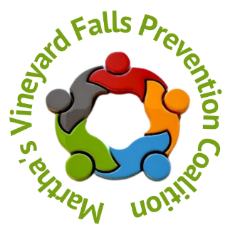
- Hosted bi-monthly meetings with the Falls Prevention Coalition and oversaw island-wide efforts for Falls Prevention Month (Sept), developing a host of print and media assets on awareness, education, and empowerment available to all island service agencies. Sept activities included in-person educational sessions across the island on “Medication and Risks”, “Safety Tips for using a Cane or Walker”, “Everything you wanted (or didn’t want) to know about Fall Risks and Falls Prevention” and “Pain-Free Movement and Balance Screening” as well as dissemination of printed materials.

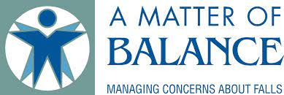
- Introduced a new evidence based pilot program, Matter of Balance, in collaboration with MVH and the COAs. Secured over $5,000 in funding to identify and train coaches (COA and MVH staff as well as volunteers) and launched 2 8 week sessions at the Edgartown Council on Aging and the Tisbury Council on Aging. This program is specifically designed to reduce the fear of falling and improve activity levels among Aging Adults and addresses an existing service gap in supporting those who have fallen and are restricting their activities as a result.

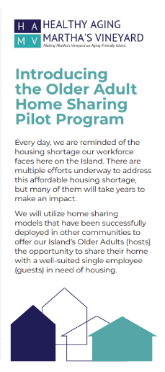

- Designed and introduced a “proof-of-concept” Home Sharing program to pair Aging Adults who live alone (the host) with an employed Islander (the guest) who needs housing. Modelled after nationwide programs, we are in the early stages of getting this program off the ground. Partnering with MV Mediation to provide housing facilitation expertise to insure a quality “match” between participants.

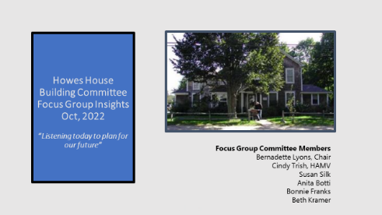

- Partnered with the Howes House Building Committee, conducted 6 focus groups with Aging Adults and service agencies to ensure that Aging Adult perspectives are included in renovation considerations as well as surfacing other opportunities to broaden service utilization.

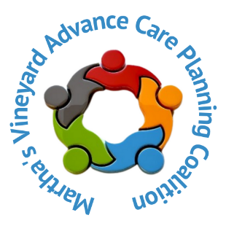
- Continued to educate and provide educational seminars for Advance Care Planning, strengthening our partnership with MVH and other health care providers, raising the percentage of Aging Adults with PCPs at MVH who have completed Health Care Proxies to 34%. 75% of those who attended educational seminars led by HAMV went on to complete a Health Care proxy.

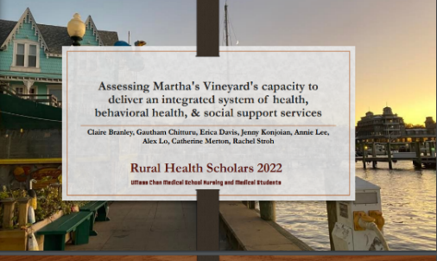

- Hosted the Rural Scholars (U Mass Chan medical and nursing students) to conduct research on the island and to socialize these findings across the island, informing prioritization and service development around the topic of in-home services.

- Advocated on behalf of other island agencies to raise awareness of Aging Adult needs and to obtain funding and demonstrate legislative support for key initiatives.

- Contributing member of numerous regional, statewide and national organizations/committees representing the Vineyard’s perspective on Aging Adult issues (e.g. Dukes County Health Council (DCHC), AARP Rural Labs, MARCH, MA Healthy Aging Collaborative, co-chair of Patient Family Advisory Council at MVH).

- Advocated on behalf of other island agencies to raise awareness of Aging Adult needs and to obtain funding and demonstrate legislative support for key initiatives.

- Supported the development of the Green House model nursing home, working with MVH and Navigator Homes to bring this 10+ year journey to completion, resulting in a 70+ bed skilled nursing home facility on-island that is available to residents at all income

